

**BLG 433E**

**COMPUTER COMMUNICATIONS**

CRN: 12337

**PROJECT #1**

Submission Date: 06.11.2014

**GROUP MEMBERS:**

TUĞRUL YATAĞAN 040100117

EMRE GÖKREM 040100124

1. **Implementation**

We created 2 thread for each station: stationA, stationB

Thread stationA controls function of A station:

* Control time
* Create AtoB thread
* Update sent value of frame

Thread stationB controls function of B station:

* Control time
* Create BtoA thread
* Update sent value of Ack

Addition of these thread, we use threads to send frame and ack. One frame is sent to B with AtoB thread by A. This thread controls sending frame event:

* Control time
* Control error
* Update receive value of frame

One Ack is sent to A with AtoB thread by B. This thread controls sending Ack event:

* Control time
* Control error
* Update receive value of Ack

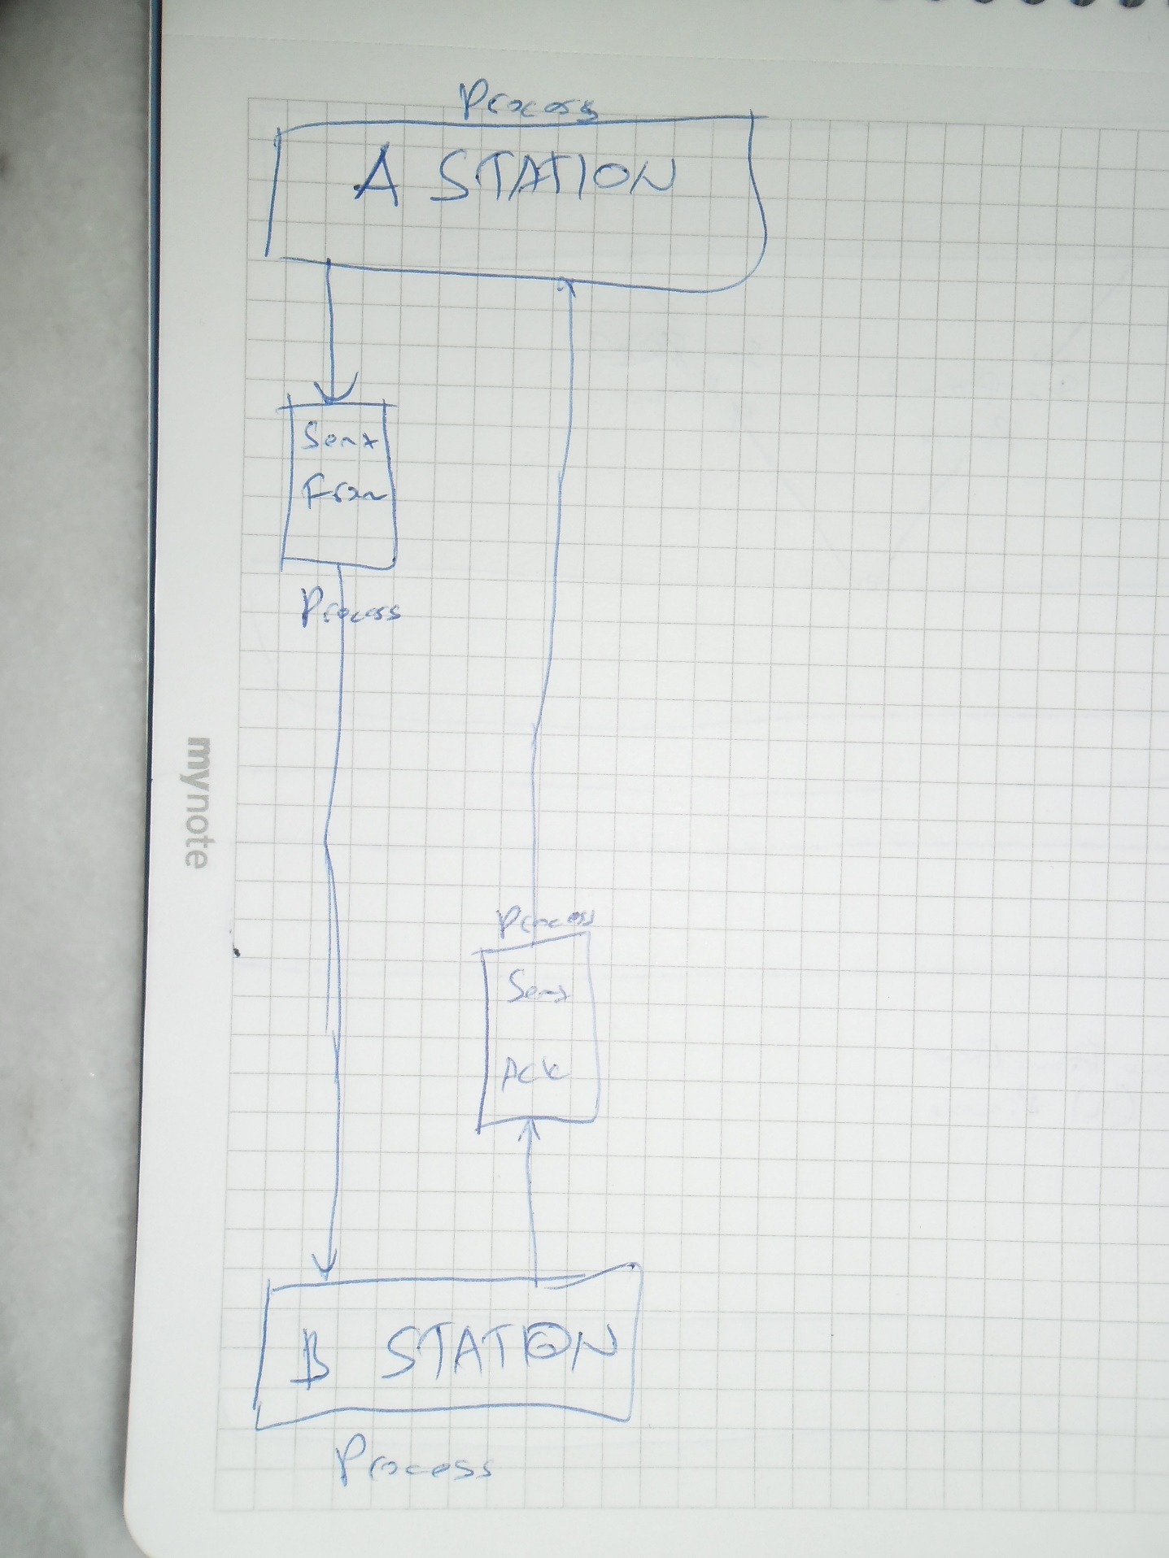

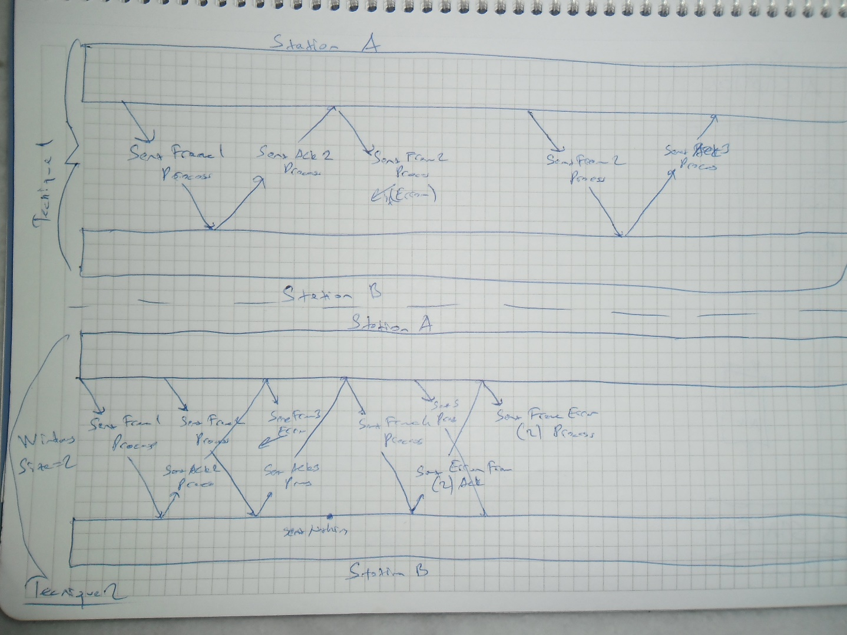

Implementation of technique 1 and 2 are done thanks to these thread.

1. **Size of Sliding Window in Technique 2**

Size of sliding window is number of sending frame in delay route time (540ms). For test data, these values are 4 and 2 so we sent 4 and 2 frame between this times. Each frame is 1 bit and line capacity is 1mbps. So we can send 1^6 frame in this time.

1. **Size of Buffer in Technique 2**

Size of buffer is number of receiving frame in delay route time (540ms). For test data, these values are 4 and 2 so we sent 4 and 2 frame between this times. Each frame is 1 bit and line capacity is 1mbps. So we can receive 1^6 frame in this time.

1. **Maximum Windows Size for Technique 2**

Windows size <= 2^m

m = sequential data size

m values for our example = 1000

So we can use windows size = 1000.

1. **Error Rate – Simulation Time**

If error rate is bigger, we lose more time. Because we wait for timeout (550ms).

Lost time = 550* number of error

